**CS5542 Big Data Apps and Analytics**

**LAB ASSIGNMENT #1**

1. Problem Set-1
2. Draw a Software Architecture diagram and design workflow for the chimpanzee monitoring problem of the Problem Set 1 (PS-1). (Duplicate of PS-1)
3. Write a pseudocode for the **Odd Man Out problem of** the Problem Set 1 (PS-1)

**Pseudocode:**

Set A as the array of unsorted numbers

Set a variable called ArraySum and initialize to zero

Set B as an empty dynamic array

For every number in Array A

Check if number is in Array B

If the number does not exist in Array B

Add the number to Array B

Add the number to ArraySum

Else

Subtract integer from ArraySum

ArraySum is the odd man out

1. **Create GitHub Account**. Create a repository in remote Github. Clone it to local machine.

Create 2 (Source and Documentation) directories in local github.

Put the document with the pseudo code of question (1) under documentation directory in the local windows Github and sync it to remote Github.

Link to Repository: <https://github.com/rah59/BigDataSpring2017>

Snapshots:

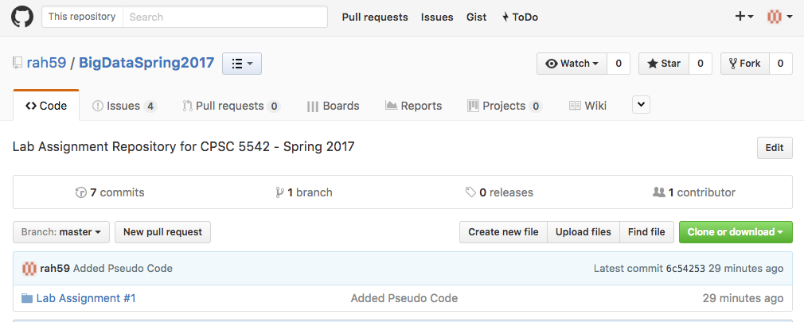

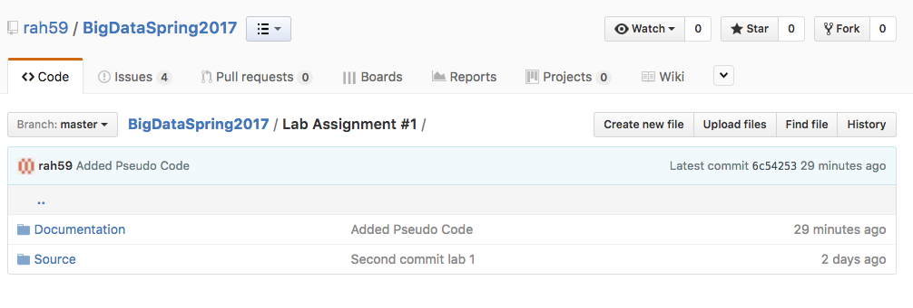

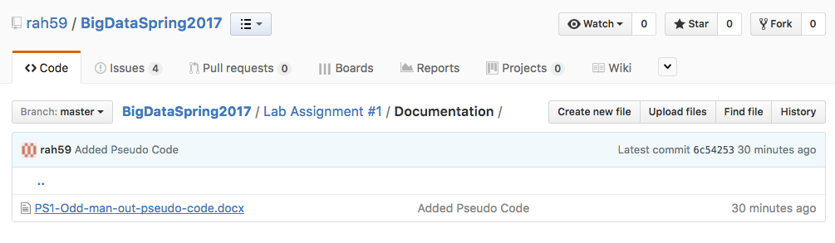

1. **Create ZenHub Tool Account**. Create a board, 3 iterations, at least 5 tasks and show the analytics graph.

Link to Repository: <https://github.com/rah59/BigDataSpring2017>

